

**Individual Assignment Cover Sheet**

*You must keep a photocopy or electronic copy of your assignment.*

|  |  |  |  |  |
| --- | --- | --- | --- | --- |
| Unit name: | Front-end Web Design | | | |
| Unit code: | 11056 | | | |
| Semester: | 1 | | Year: | 2019 |
| Tutor’s Name: | Riley Post | | | |
| Tutorial Day and Time: | Tuesday 8:30am | | | |
| Assignment Name/Number: | | Assignment 3 – Accessibility Audit | | |
| Case Study Name and Number: | | Front-end Website | | |

**I declare that this assignment is solely my own work, except where due acknowledgements are made. I acknowledge that the assessor of this assignment may provide a copy of this assignment to another member of the University, and/or to a plagiarism checking service whilst assessing this assignment. I have read and understood the University Policies in respect of Student Academic Honesty.**

|  |  |  |  |  |  |  |  |  |
| --- | --- | --- | --- | --- | --- | --- | --- | --- |
| Student ID: | u | 3 | 1 | 6 | 1 | 7 | 3 | 4 |

Signed: ______N.Villiers______________________Date:_________17/05/2019__________

Responsive website - Accessibility Audit

Table of Contents

Assignment Name/Number: 1

Assignment 3 – Accessibility Audit 1

Case Study Name and Number: 1

Accessibility Audit 3

1.1.1 – Non-text Content - Provide text alternatives for non-text content 3

1.3.1 – Info and Relationships - Logical structure 3

2.1.1 – Keyboard - Accessible by keyboard only 4

2.3.1 – Three Flashes or Below - No content flashes more than three times per second 4

2.4.3 – Focus Order - Logical order 5

2.4.4 – Link Purpose (In Context) - Every link’s purpose is clear from its context 5

4.1.1 – Parsing - No major code errors 6

4.1.1 – Parsing - No major code errors, continued… 7

4.1.1 – Parsing - No major code errors, continued… 8

4.1.1 – Parsing - No major code errors, continued… 9

4.1.1 – Parsing - No major code errors, continued… 10

Importance and context of accessibility 10

Summary of main accessibility issues within the site 10

Explanation of main accessibility issues 11

Explanation of main accessibility issues, continued… 12

Reference(s) 12

# Accessibility Audit

It has been determined in the course content and the assignment briefing that the website should meet the following criteria;

## [1.1.1](https://www.w3.org/WAI/WCAG21/quickref/?versions=2.0#non-text-content) – Non-text Content - Provide text alternatives for non-text content

I have ensured that, I have included alternate text for every single image which can be found in the site. Initially, I had very non-descript alternate text, but it was suggested by Riley that I include more descriptive and meaningful descriptions in the alternate text, of between one to two sentences. This is especially important to accessibility as it can allow someone who may not be able to see the image at all, or in full detail, to understand what the image is, without being able to see it. The image’s alternate text should use descriptive language, which allows the user to imagine or picture what the image might look like, in their mind. Based on this, I concur that the website I have created passes this standard. See the source image

## [1.3.1](https://www.w3.org/WAI/WCAG21/quickref/?versions=2.0#info-and-relationships) – Info and Relationships - Logical structure

This point relates to how well the meaning of non-text elements is represented by the elements surrounding them, for example, by using captions, headings, paragraphs or any other text element which can provide insight to the context of the element. The most common way this can be done is by using semantic HTML, wherein the name of the element describes its function, for example an <img> tag contains an image, and this can be determined using a screen reader. I have attempted to ensure that there are no elements in my website which do not conform to semantics. Based on this, I concur that the website I have created passes this standard. See the source image  
[1.3.2](https://www.w3.org/WAI/WCAG21/quickref/?versions=2.0#meaningful-sequence) – Meaningful Sequence - Present content in a meaningful order

The content of the website is presented in a standard and conventional way, with all text read left to right, and paragraphs read top to bottom. There are no instances where the meaning changes based on where the element is positioned, no white spaced used for spacing, and does not use a layout which does not make sense, when the viewport width changes. Because the design passes all of these criteria, I am satisfied that the website I have created meets this criterion. See the source image  
[1.4.1](https://www.w3.org/WAI/WCAG21/quickref/?versions=2.0#use-of-color) – Use of Colour - Don’t use presentation that relies solely on colour

There are no instances in my website where a specific colour or tone is used to convey meaning within the website and a contrast ratio of at least 4.5:1 has been used between all text elements and their containers. This being the case, I assess my website as passing this criterion. See the source image  
[1.4.2](https://www.w3.org/WAI/WCAG21/quickref/?versions=2.0#audio-control) – Audio Control - Don’t play audio automatically

There is no audio, whatsoever used in my website at all, and so it is not possible for my website to fail the accessibility audit based on this. See the source image

[2.1.1](https://www.w3.org/WAI/WCAG21/quickref/?versions=2.0#keyboard) – Keyboard - Accessible by keyboard only

The website is fully navigable via the keyboard only, and every page and section within the website can be accessed from every other page and section in the website using the keyboard only. Initially, with my design, where two separate navigation menus are used, issues were presented. I have implemented a desktop navigation menu, which appears at the top of the page in the desktop view only. I have also implemented a mobile/tablet navigation menu, which only appears when the viewport width reaches the specified breakpoints. This being the case, it was possible to use both menus, by tabbing with the keyboard. This was because I had defined the menus to be “display: hidden;”, where it should have been “display: none;”. The difference between these two properties, is that with “hidden”, the menu still is in existence and so technically can be clicked, whereas when it is set to “none” it does not exist and cannot be clicked. Changing this property allowed me to navigate the website with the keyboard, without repetition of menu link items. Initially, this criterion would not have been met, but due to the rectification of this issue, I am now satisfied that this criterion has been met. See the source image  
[2.1.2](https://www.w3.org/WAI/WCAG21/quickref/?versions=2.0#no-keyboard-trap) – No Keyboard Trap - Don’t trap keyboard users

By using the “Tab” key found on most standard “QWERTY” keyboards, the user is able to select links within the website. Once the user has focussed on a particular link, they can hit “enter” on the keyboard to click that link. If the user pressed the “Tab” key more than once, the focus will move to the next available link. Once all of the links have been cycled through, if the user continues to press “Tab”, the focus will move to the controls of the user’s browser. This continues in this pattern indefinitely, until the user navigates to the desired link, and so the user can never be trapped, once the focus is on the last link on the page. For this reason, I am confident that the user cannot become trapped when only using a keyboard for navigation and so this criterion has been met. See the source image

## [2.3.1](https://www.w3.org/WAI/WCAG21/quickref/?versions=2.0#three-flashes-or-below-threshold) – Three Flashes or Below - No content flashes more than three times per second

As there are no instances of where content flashes within my website, there are also no instances of where there are more than three flashes per second, and so this accessibility criteria have been met and satisfied. See the source image  
[2.4.2](https://www.w3.org/WAI/WCAG21/quickref/?versions=2.0#page-titled) – Page Titled - Use helpful and clear page titles

Each page found within my website has a title on the tab in the browser, at the very top of the page (in the header), and at the start of the page content. There are four pages named Home, Description, Locations and History. Home, as the name suggests, is the home page of the website and provides an introduction as to what Norfolk Island is. Description is a page which describes Norfolk Island and Its surroundings. Locations describes all of the locations that can be found on Norfolk Island. History is a page which describes, in detail, the history of Norfolk Island. These names, used as page titles, give a clear meaning for what each page is related to or about, and so was assessed as passing the criteria. See the source image

[2.4.3](https://www.w3.org/WAI/WCAG21/quickref/?versions=2.0#focus-order) – Focus Order - Logical order

This criterion is primarily concerned with the order in which content is placed, and how that affects the meaning of it. An example might be in a recipe, where the steps or instructions are not in numerical order, which affects the success of the recipe. In the case of my website, I have ensured that the images which I have included are belonging to the paragraphs which they are contained within. Beside this, there are no other obvious sequences or order in which the content needs to be configured to maintain its meaning and so I have assessed this website as passing this criterion point. See the source image

[2.4.4](https://www.w3.org/WAI/WCAG21/quickref/?versions=2.0#link-purpose-in-context) – Link Purpose (In Context) - Every link’s purpose is clear from its context

Much like with the title, each link must have a clear direction and purpose. This is so that when a user is trying to navigate to a specific part of the website, they are able to without having to click on links, and trying to predict where the information or page that they need, can be found. I have named all of the links in the website as the same names as the page that they are linking to. The only exception to this is the “Back to top” link found in the footer of each page, which returns the user to the top of the page, that they are currently on. I would suggest that, for these reasons the website passes on this point. See the source image  
[3.1.1](https://www.w3.org/WAI/WCAG21/quickref/?versions=2.0#language-of-page) – Language of Page - Page has a language assigned

This point is important, especially when a user is using a screen reader or translator. It allows the system, that the user is using to identify the language in which the page is written, to be used to help navigate through the site or translate the site. I have included ‘[lang="en"]’ in the opening HTML tag of each page for this reason. Because each page in the website contains this and so the language is declared as being English, this criterion is met. See the source image

## [4.1.1](https://www.w3.org/WAI/WCAG21/quickref/?versions=2.0#parsing) – Parsing - No major code errors

Initially the code in all 4 of my pages, failed, due to not validating for multiple errors and warnings. These errors were mainly regarding using <h1> headings as anything other than top level headings and having sections with <h1> headings instead of <h2>-<h6> headings. Two other errors or warnings which were made apparent, were that unordered lists are not legally allowed to be child elements of a span, and duplicate classes also existed. These errors and warnings can be seen in the screenshots below.

The following image shows the errors and warnings for the home page.

## [4.1.1](https://www.w3.org/WAI/WCAG21/quickref/?versions=2.0#parsing) – Parsing - No major code errors, continued…

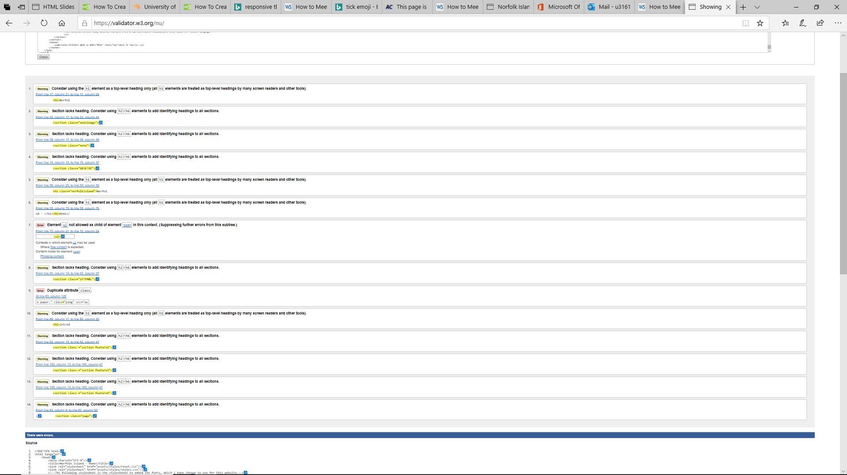.

## [4.1.1](https://www.w3.org/WAI/WCAG21/quickref/?versions=2.0#parsing) – Parsing - No major code errors, continued…

This screenshot shows the errors and warnings that were returned for the description page.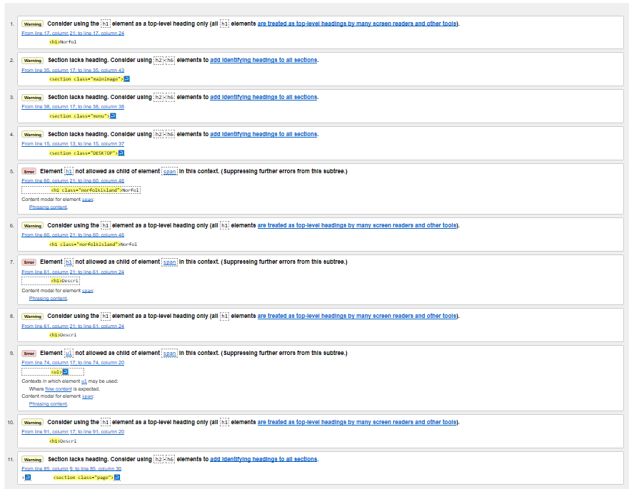The next screenshot shows the errors and warnings that were returned for the History page.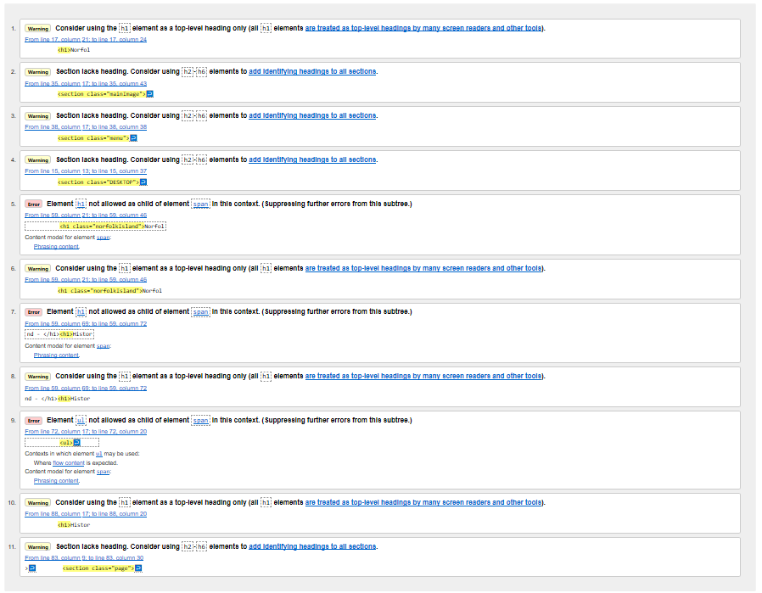

## [4.1.1](https://www.w3.org/WAI/WCAG21/quickref/?versions=2.0#parsing) – Parsing - No major code errors, continued…

Finally, the screenshot below, shows the errors and warnings returned for the Locations page.

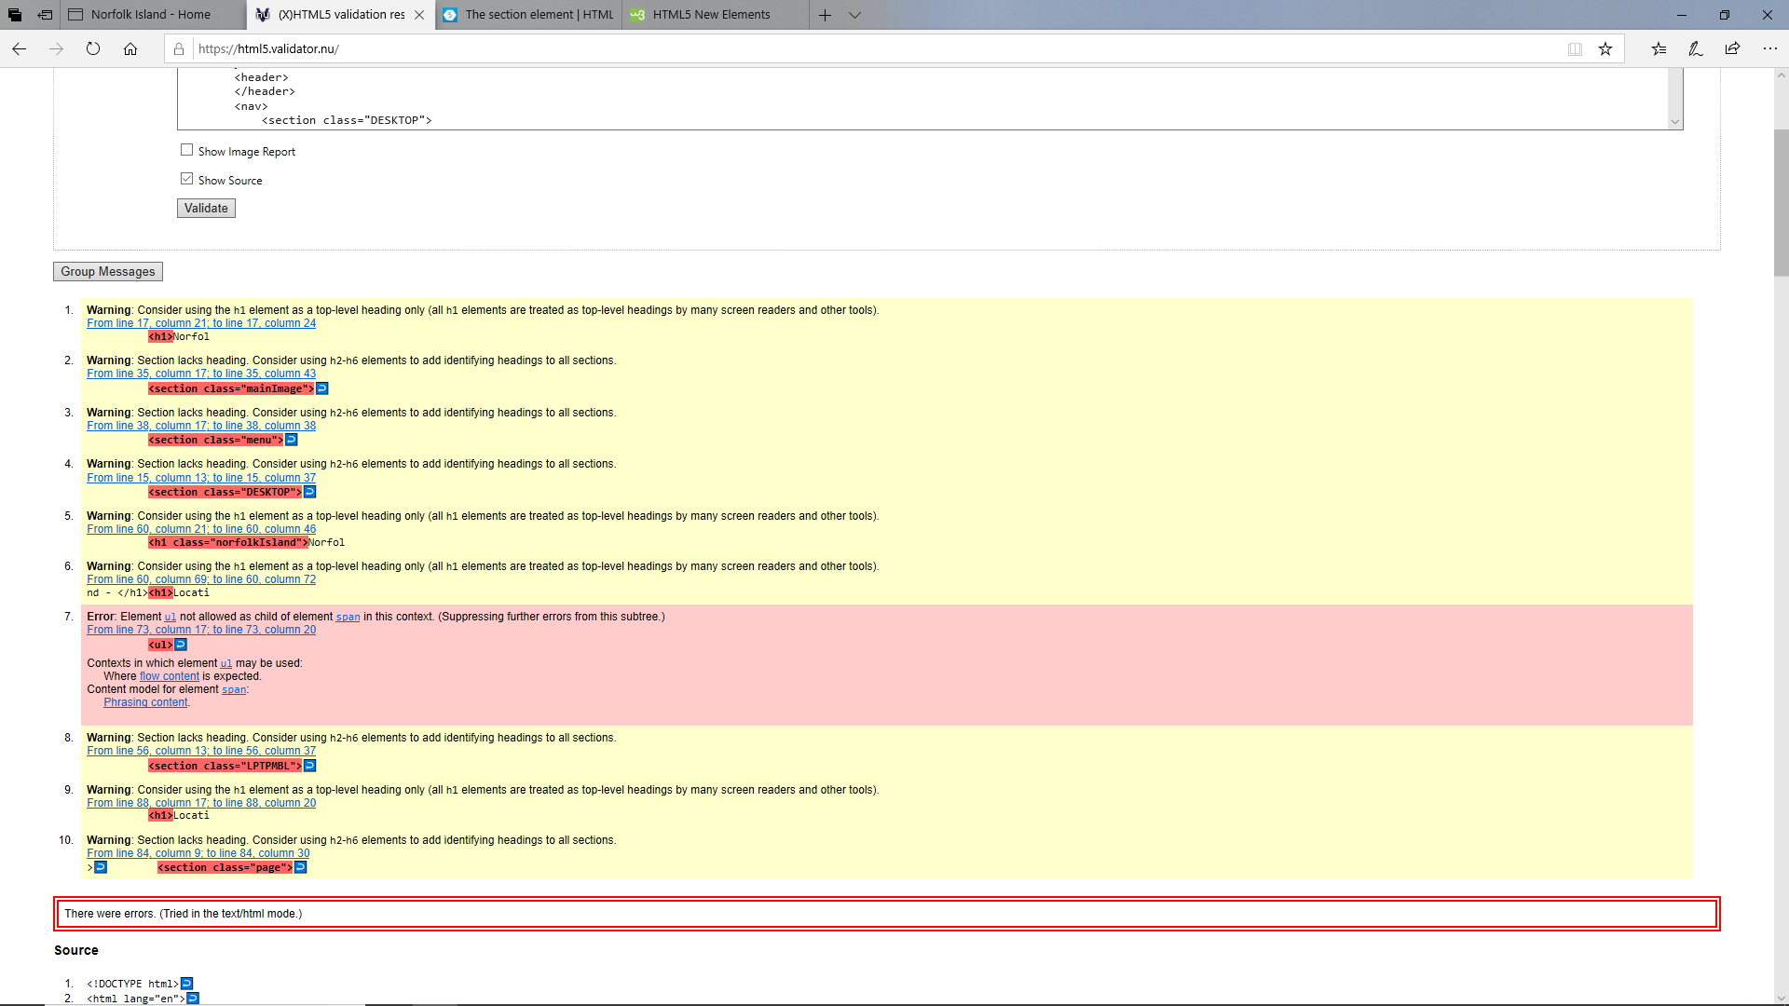

After rectifying all errors in the HTML code, my website has validated according to HTML WCAG 2.0 semantic standards. This being the case, there are still a few warnings. These warnings exist because I have used sections, which do no not contain headings, and one warns against using a <h1> heading, unless it is for a top element, which it is. It is important that the <h1> elements are reserved for the top of the page because some screen readers use the <h1> element to locate the top of the page.

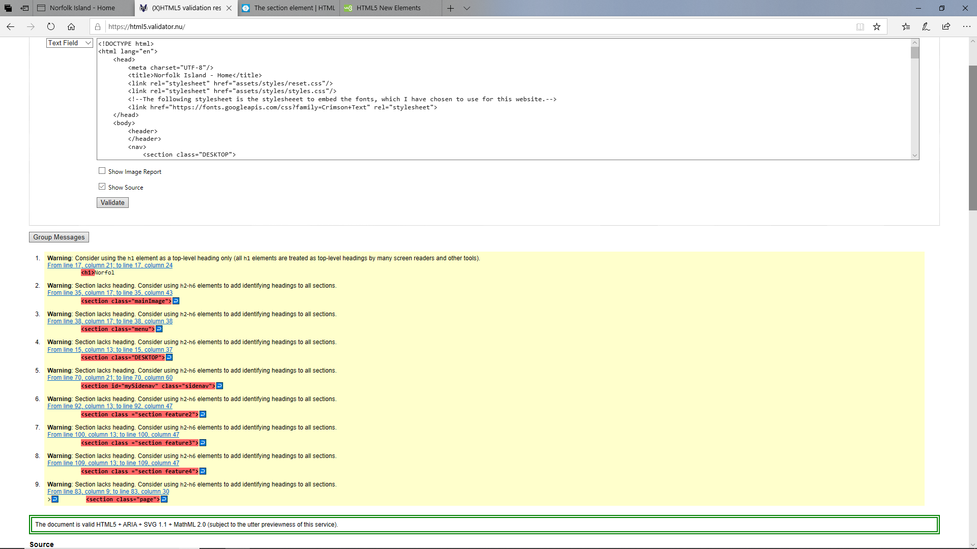

Although, when first semantically tested, the website did not meet requirements outlined in this part of the accessibility audit, I am confident that, after rectifying these errors that the website sufficiently meets these requirements. See the source image

## [4.1.1](https://www.w3.org/WAI/WCAG21/quickref/?versions=2.0#parsing) – Parsing - No major code errors, continued…

Overall, the website has proven viable, and that it can adhere to the WCAG 2.0 AA standards set out for the requirements of this assignment and I therefore confirm that this website passes these requirements.

On top of manually checking against these standards, I have checked my website using the Web Accessibility Checker, found at <https://achecker.ca/checker/index.php> .

# Importance and context of accessibility

The world wide web (W3) is intended to be used by all people regardless of ability, age, location, language, hardware, etc. Accessibility is primarily focussed on providing this to people who from varying levels of sight, hearing, movement, cognitive ability, or any other impairment. Having a disability has a large impact on the ability of someone to use a website effectively, and badly designed web sites can create barriers which exclude people from minorities, or with disabilities from using the web. It is vital that developers and organisations create high-quality websites, which do not exclude or prevent anyone from using the site.

Web accessibility can be defined as being websites, tools, and different technologies, which are designed with the intention of being used by people with disabilities in a way that is easier than when using a website that is not accessible. Web accessibility enables people with disabilities to perceive, navigate, interact and understand the web and internet. On top of this people with disabilities should not only be able to access and use the web, but also make contributions to the web. The types of disabilities which are usually considered when developing accessible websites are auditory, cognitive, neurological, physical, speech and visual impairments or deficits. Some common examples of web accessibility, for people who don’t have disabilities might include;

* Elderly persons with changing abilities, attributed to old age.
* People with non-permanent disabilities, such as someone with a broken arm.
* A person in an environment where they cannot hear the audio being played, because it is too noisy where they are.
* People who may have a slow internet connection

The web and internet are becomingly increasingly relied upon in society and so it is important that as we grow more dependent on the web, that people who have disabilities do not become even further disadvantaged by their disability, instead we must strive to make websites and the internet accessible and usable by these people.

# Summary of main accessibility issues within the site

As explained in the accessibility audit, the main issues which I had encountered when performing accessibility testing were the contrast of the text used in paragraphs, to their container’s backgrounds, the multiple duplicate menu links that could be used when navigating using a keyboard only, and the validation errors which were made apparent when I validate the pages during the accessibility audit. These three issues together would have made it extremely hard, confusing and frustrating for a user with a disability to navigate or use the website.

# Explanation of main accessibility issues

These issues have the following effects, if not rectified;

* Low contrast of text on section backgrounds;

If the contrast of the text was not checked, this may have presented issues for users who have optical issues or vision impairment. To avoid issues related to low contrast I have checked each section and its text to against the contrast checker found at <https://webaim.org/resources/contrastchecker/>.

On top of this I have also used the “”no Coffee” plug-in for google chrome which allows the user to simulate optical impairments and disabilities to ensure that the site is usable to persons who possess these.

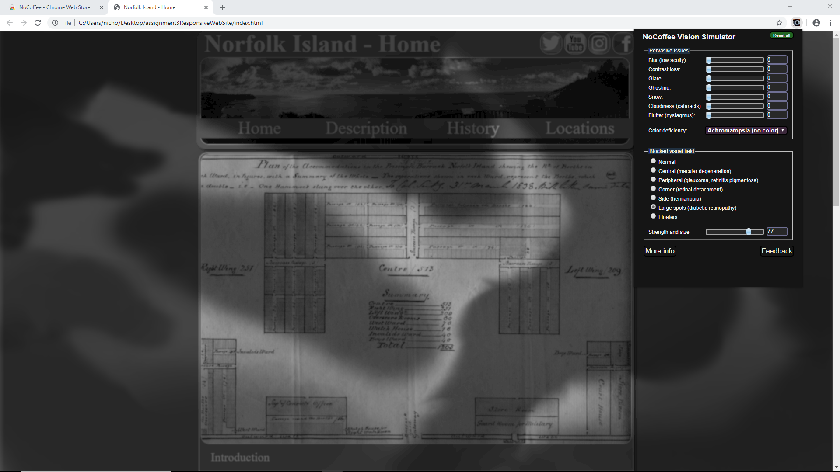

* Duplicate menu links when using keyboard only, for navigation;

Due to two separate navigation menus being used, I have configured my media queries so that only one is displayed at a time. This being the case, both were originally still navigable when using keyboard only. This is because I had set the desktop menu to be hidden when the laptop/mobile menu is shown. I should have however, set it to be “display: none;” rather than “display: hidden;” in the CSS, so that instead of just not being visible, the menu would not be created and therefore could not be click. If I did not rectify this issue, this could have been very confusing for a user who is trying to navigate the site using only the keyboard. If the user was using a screen reader, this also would prove problematic, as there would be two elements with the exact same names, but in different locations, making navigation very confusing and hence not very accessible at all.

# Explanation of main accessibility issues, continued…

* Validation errors when checked during accessibility audit;

Because I had not placed headings in some of the sections, validation errors were returned when validating as part of the accessibility audit. Apart from returning errors, not having headings provided for content makes navigation hard for users who are vision impaired and may be relying on screen readers to find a particular place in the page, or piece of information. This would prove impossible, if there were no headings in place throughout the page and the screen reader would have to instead perform a linear search of the entire page to locate what the user was searching for.

# Reference(s)

WebAIM: Color Contrast Checker. 2019. WebAIM: Color Contrast Checker. [ONLINE] Available at: [https://webaim.org/resources/contrastchecker/.](https://webaim.org/resources/contrastchecker/). [Accessed 17 May 2019].